

NMAM INSTITUTE OF TECHNOLOGY

(A unit of Nitte Education Trust)

Nitte - 574 110, Karkala taluk, Udupi Dist., Karnataka

# Department of Computer Science and Engineering RDBMS PROJECT REPORT ON

**PATIENT DATABASE MANAGEMENT SYSTEM**

***PROJECT ASSOCIATES***

**Shreevani Bairy : 4NM18CS177 Shreya S Kotian : 4NM18CS179 Shreyas K Shetty : 4NM18CS181 V SEM, Sec 'D'**

**Dept of C.S.E**

**PROJECT GUIDE**

**Mr. Pradeep Kanchan**, **Department of C.S.E. NMAMIT,Nitte**

# ABSTRACT

‘Inside Illusions’ is the web application of a Interior Designing Company where customers can contact the particular designing company by sending their contact information. This application is created to help the Interior Designing Company owners and customers for the future communication. Customers can also view the work of the particular company.

This is the website of the Interior Designing Company named ‘Inside Illusions’. Here the first page is the Home page which consists of the information related to Interiors. The Home page consists of three more options like Search, About Us and Contact Us. ‘Search’ is used to search the information which customer wish to search. ‘About Us’ gives all background information and work information. ‘Contact Us’ redirects to the page where users can send a mail to the Interior Designing Company. So this website can be used by the people who wish to renovate their house, complex, shops and offices or any other Interior decor related work.

# TABLE OF CONTENTS

|  |  |
| --- | --- |
| **Chapter** | **Page no.** |
| **1. CERTIFICATE** | **4** |
| **2. ACKNOWLEDGEMENT** | **5** |
| **3. INTRODUCTION** | **6-7** |
| **4. PROBLEM STATEMENT** | **8** |
| **5. DATABASE DESIGN** | **9-10** |
| **6. FRONT END TECHNOLOGY** | **11** |
| **7. BACK END TECHNOLOGY** | **12** |
| **8. SCREENSHOTS** | **13-15** |
| **9. CONCLUSION** | **16** |
| **10.REFERENCES** | **17** |

## CERTIFICATE

Certified that the project work carried out by Shreevani Bairy (4NM18CS177) , Shreya S Kotian(4NM18CS179) and Shreyas K Shetty(4NM18CS181) bonafide students of NMAM Institute of Technology, Nitte in fulfilment for the Relational database Management System lab in Computer Science and Engineering during the academic year 2020-2021.

Signature of the Examiners: Signature of the Guide:

1.

2.

## ACKNOWLEDGEMENT

The satisfactions that accompany the successful completion of any task would be incomplete without the mention of the people who made it possible. So we acknowledge all those whose guidance and encouragement served as a beacon of light and crowned our efforts with success.

We are thankful to our project guide, Mr. Roshan Fernandes, Dept. of CSE for his valuable guidance and advice. His willingness to motivate us contributed tremendously to our project.

We would like to place on record our deep sense of gratitude to Dr. K. R. Udaya Kumar Reddy, HOD-Dept. of Computer Science and Engineering, NMAMIT, Nitte for his generous guidance, help and useful suggestions. We also acknowledge and express our sincere thanks to our beloved Dr. Niranjan. N. Chiplunkar, Principal, NMAMIT, Nitte who is a source of inspiration to us.

We thank all the Teaching and Non-Teaching staff members of the department of CSE for providing resources for the completion of the project. A special thanks goes to our parents, friends and relatives for supporting and encouraging us in all ways thus making our project successful. Finally, we thank all those who have contributed directly or indirectly in making this project a grand success.

|  |  |  |
| --- | --- | --- |
| Shreevani Bairy | Shreya S Kotian | Shreyas K Shetty |
| (4NM18CS177) | (4NM18CS179) | (4NM18CS181) |

**CHAPTER 1**

## INTRODUCTION

INTRODUCTION

In the Interior and Furniture Design Business, the only way to get more clients is by showing your work to them. This work can be shown in advertisements, billboards or the most predominant one website. This project aims at creating a website for Interior and Furniture Design business, to increase the customer base and show their work. Interior design website needs to be as user-friendly, inviting, and inspiring as possible. Solving the real life problems is another key issue.

It is a website through which:

A user, according to its requirements & budget can browse through a catalogue of designs and decide what he wants for his furniture and designing requirements.

Web development is a broad term for the work involved in developing a website for the Internet or an intranet. Web development can range from developing the simplest static single page of plain text to the most complex web-based internet applications, electronic business, and social network services. This can be anything in term of Website Designing. Actual HTML Coding or programming of the web pages, back-end programming of the web applications and any custom web server

configuration files. Generally, under web application development refers to non-web design work such as programming and coding for the websites. In the market there are lots of web development software and web development application available for the custom web developments.

FEATURES

* Login page for Admin
* Index page for displaying menu
* Menu page for performing different operations
* Forms for contacting different interior designers
* Admin page for performing update and delete operations

PROJECT OBJECTIVES

With the development of this project, we aim to meet the following objectives:

* To facilitate commitment and productivity, removing obstacles, and motivating site visitors.
* To make sure whether the front-end part and overall system will meet the project requirements.
* To align projects to business goals, managing stakeholders, and communicating project status, milestones and unexpected difficulties effectively.
* To identify targeted audience group and reach them out through marketing ideas.
* To define the project, building its comprehensive work plan, and managing to the budget.
* To ensure website will work fine, get updated daily and used by visitors.
* Cloud computing.

**CHAPTER 2**

**PROBLEM STATEMENT**

PROBLEM STATEMENT

The website for Interior Design Company must be responsive to all the devices. It should contain all the information about the projects, awards and portfolios that the company wants to be provided. The contact page is the main feature of the website as it directly leads to the promotion and working of the company.

SIGNIFICANCE OF INTERIOR DESIGN DATABASE:

A user, according to its requirements & budget can browse through a catalogue of designs and decide what he wants for his furniture and designing requirements. To provide opportunity to make your and other’s life easy innovate ideas and techniques.

This will be helpful for the customers to know background details of the company and helps them to contact them if required. This website also helps in the development of the company.

**CHAPTER 3**

**ER-Diagram**

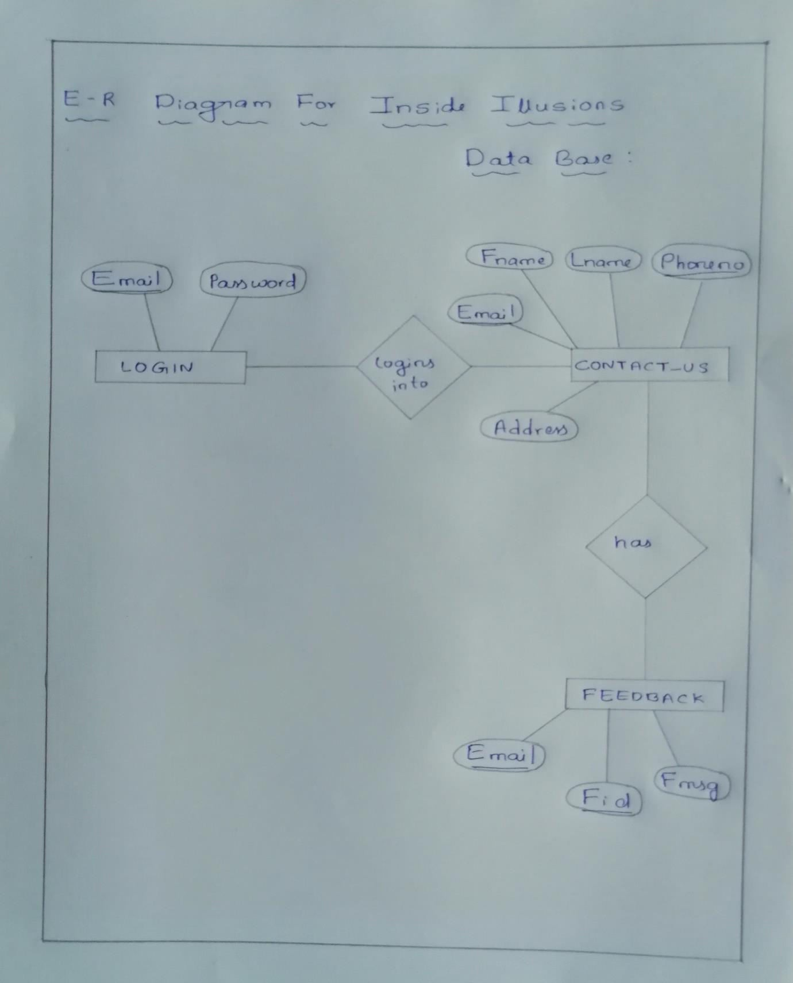

**SCHEMA**

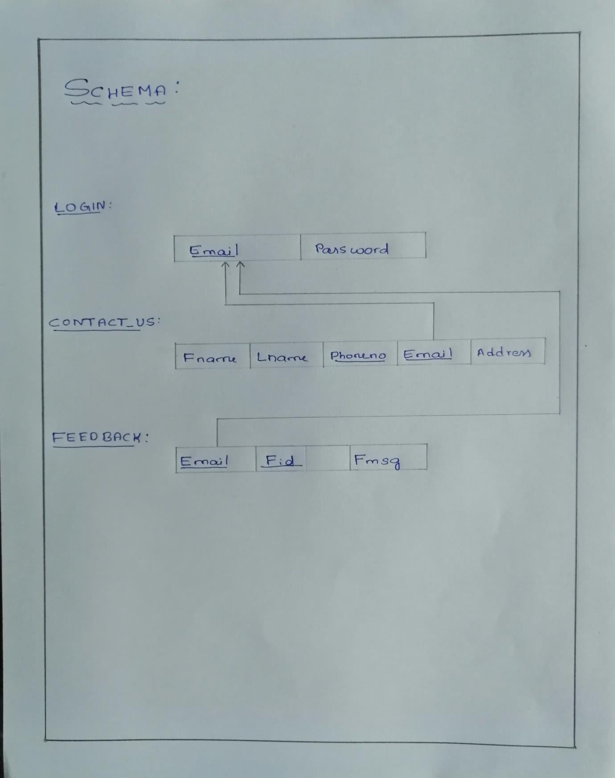

**CHAPTER 4**

**FRONTEND TECHNOLOGY**

**List of technologies for frontend**

VISUAL BASIC.NET

VB.NET is a multi-paradigm, object-oriented programming language, implemented on the NET Framework. Microsoft launched VB.net in 2002 as the successor to its original Visual basic language. Although the “.NET” portion of the name was dropped in 2005, this article uses “Visual basic [.NET]” to refer to all visual Basic languages released since 2002. It is one of the main languages targeting the .NET framework.

**CHAPTER 5**

**BACKEND TECHNOLOGY**

**List of technologies for Backend**

### Database:

Microsoft SQL Server is a relational database management system developed by Microsoft. As a database server, it is a software product with the primary function of storing and retrieving data as requested by other software applications which may run either on the same computer or another computer across a network.

**Chapter 6**

### LOGIN PAGE:

**SCREENSHOTS**

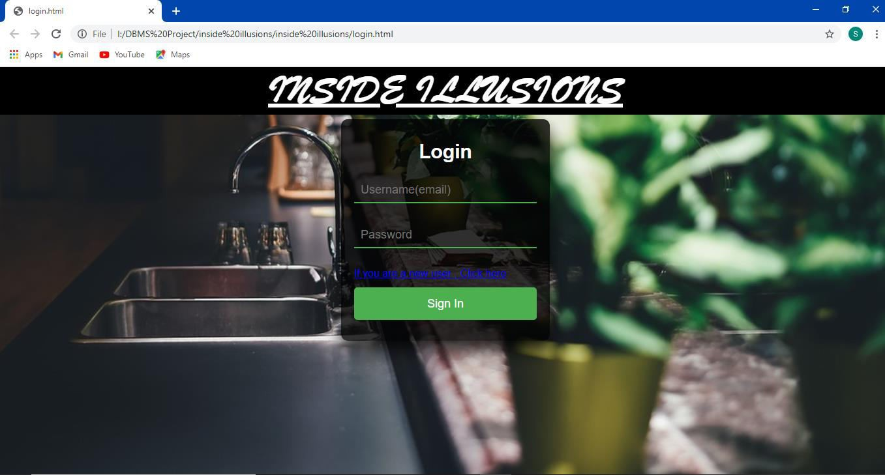

### SIGN UP PAGE:

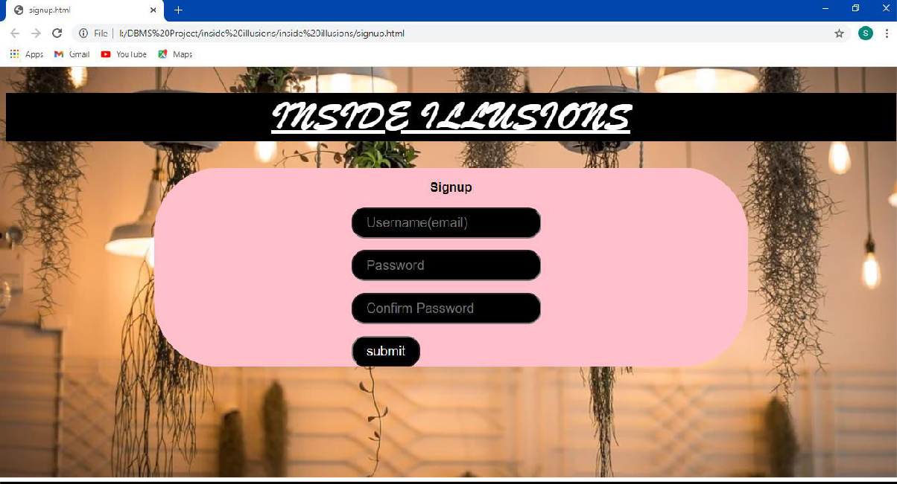

**HOME PAGE:** The first page of our website is the Home Page which is the index page of the website. It consists of three options like Search, About Us and Contact Us. It also consists the information related to Inside illusions Company.

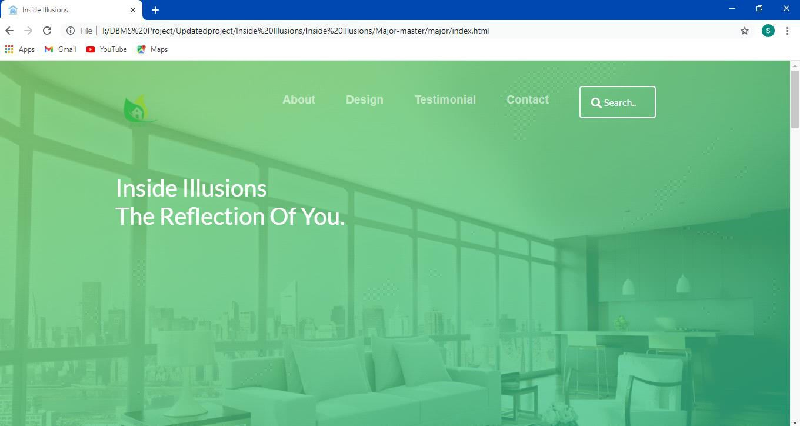

**GALLERY:** This is the gallery of the interior designing website. Here all the pictures are displayed of different types of interior designs available.

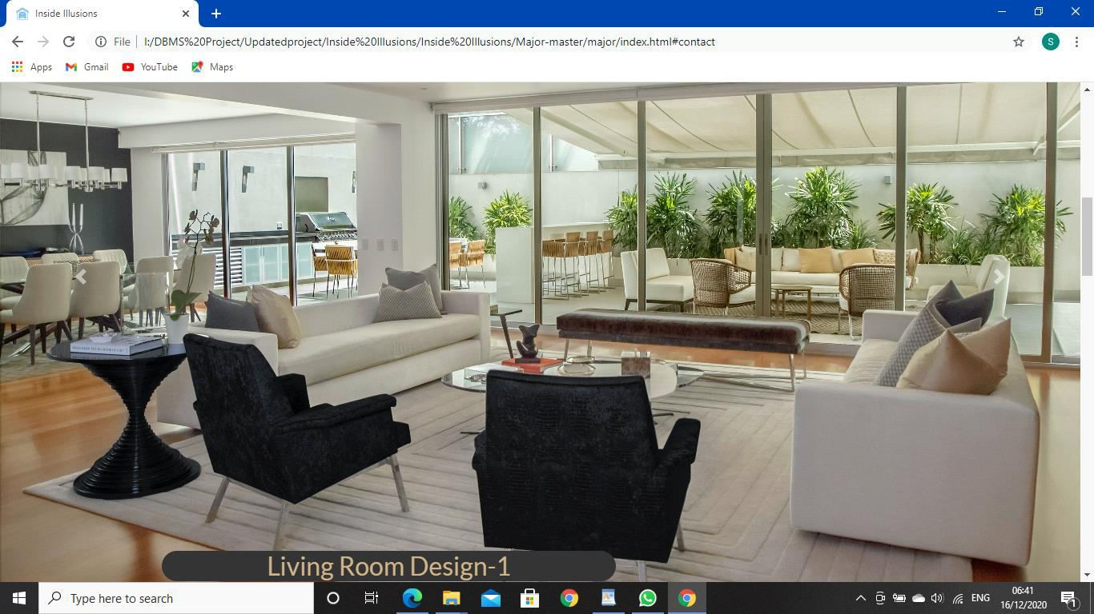

**ABOUT US PAGE:** This page gives all the background and work information. It consists of Our Motto, Who We Are, Our Commitments and also the information about our Team.

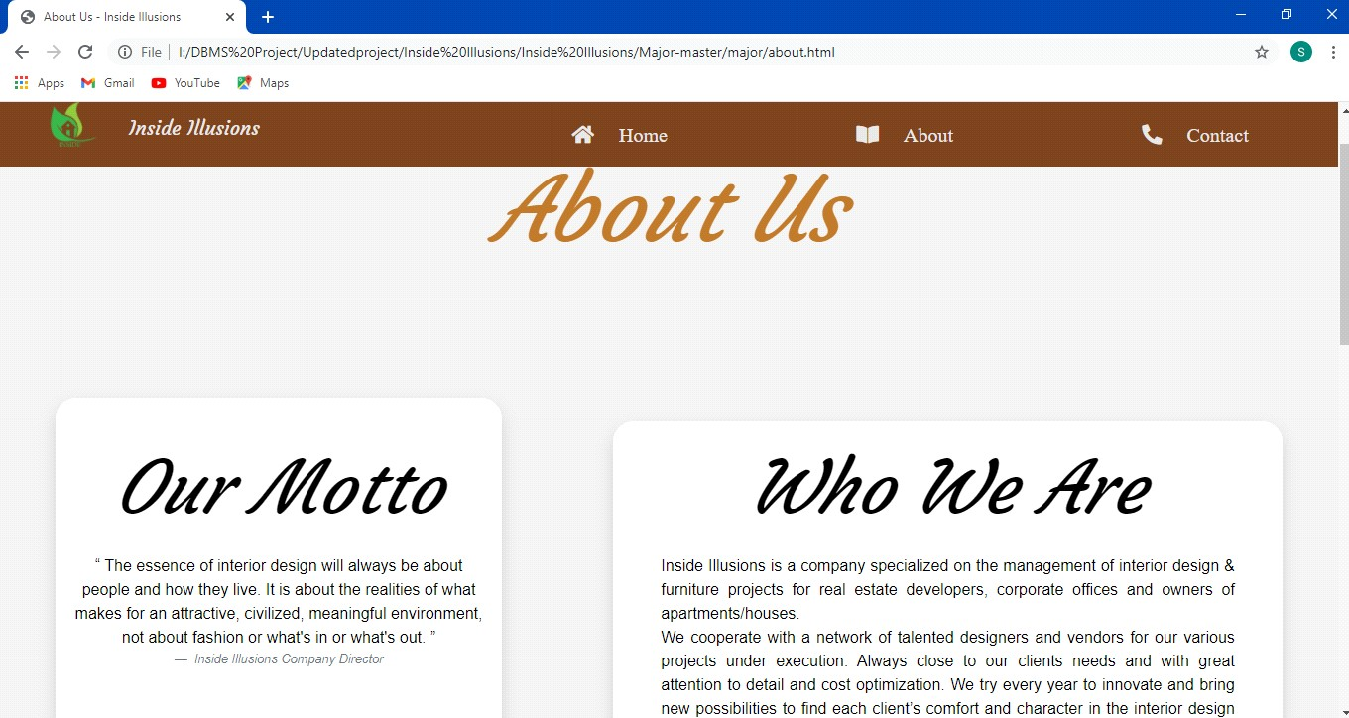

**CONTACT US PAGE:** Any customer can contact the INSIDE ILLUSIONS team to get an appointment according to their choice and can send the mail. The INSIDE ILLUSIONS team will contact them shortly.

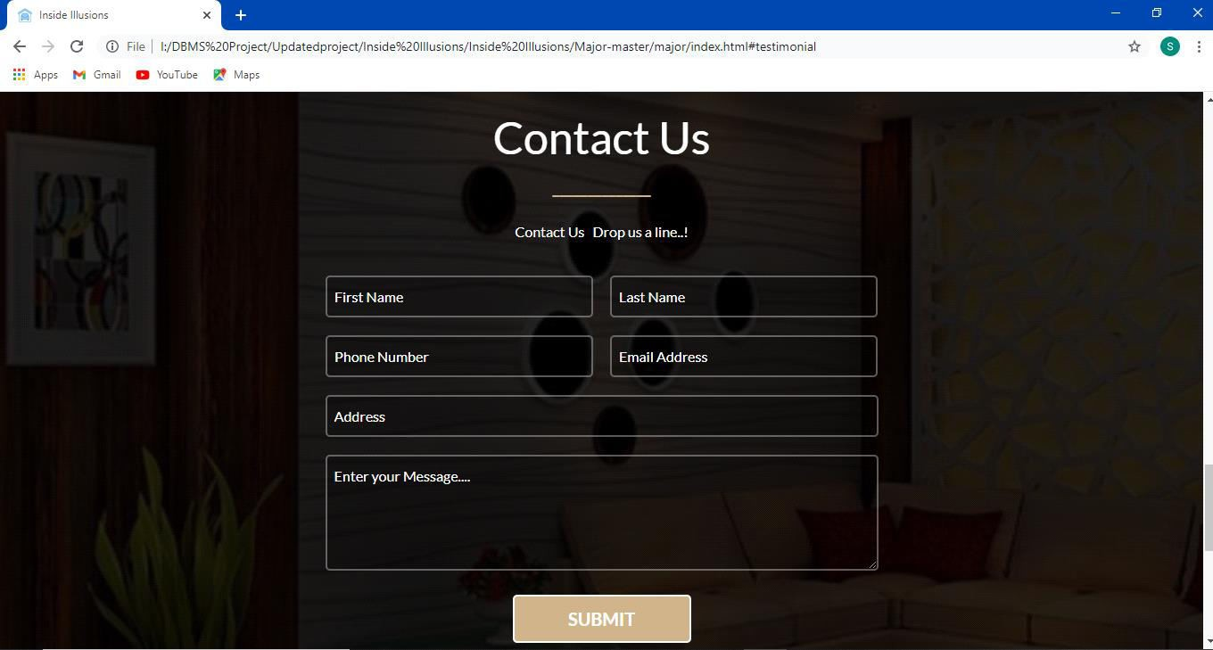

**CHAPTER 7**

**CONCLUSION**

This website provides the base for the easy two-way communication. This will be helpful for the customers to know background details of the company and helps them to contact them if required. This website also helps in the development of the company.

The future scope for this project includes the following:

* To provide opportunity to make your and other’s life easy innovate ideas and techniques.
* Generate high growth, investment and significant profits.
* Providers focus on the local market, export-oriented providers (e.g. offshore center) and hybrid providers.
* Potential rewards can be determined easily.
* Leadership opportunities.

**CHAPTER 8**

**REFERENCES**

1. [**www.w3schools.com**](http://www.w3schools.com/)
2. [**www.tutorialspoint.com**](http://www.tutorialspoint.com/)
3. [**www.WordPress.org**](http://www.wordpress.org/)
4. [**www.wpbeginner.com**](http://www.wpbeginner.com/)
5. [**www.quora.com**](http://www.quora.com/)